Experiment 4: Momentum and Impulse

Amanda Wei

505 106 664

05/17/2019

Thursday 8am

Steve Mendoza

John Field

**Discussion**

Mass of glider and flag:

*m =* 202.0±0.05 *g* = 0.2020±0.00005 kg

Flag length:

*l =* 3.80±0.05 *cm =* 0.0380±0.0005 *m*

Force sensor calibration constant: *c* = -6.2369±0.03 *N/V*

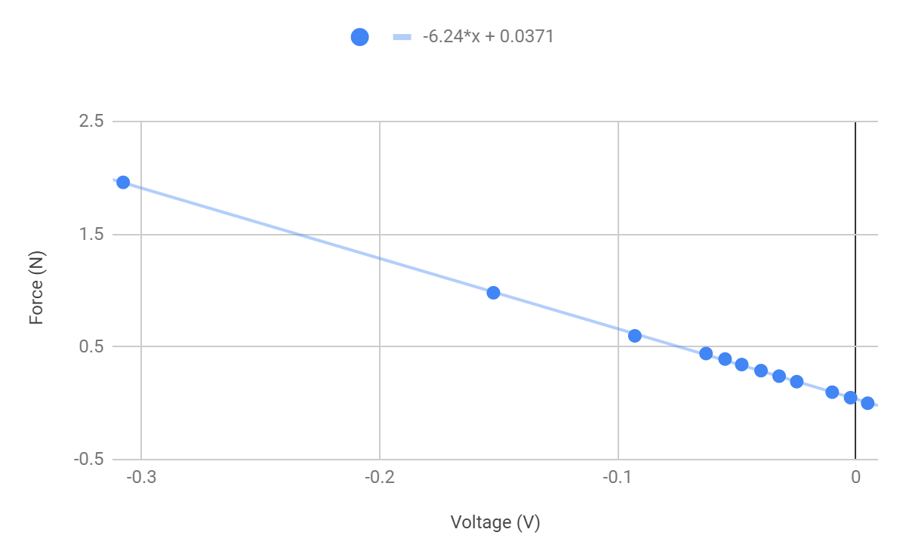

**Figure 1. Force Sensor Calibration** Twelve masses were attached to the force sensor, and the voltage readings recorded. In this graph, each blue dot represents each mass was multiplied by 9.8 plotted against its respective voltage reading. A line of best fit shows that the constant *c* relating $F=cV$ is -6.2369±0.03 *N/V.*

Method 1:

Using the formula for impulse: $Δp=m(v_{f}-v_{i})$

Derivation of uncertainty:

$δv=\sqrt{{δv}_{i}^{2}+{δv}_{f}^{2}}$

$δp=|p|×\sqrt{{(\frac{δm}{|m|})}^{2}+{(\frac{δv}{|v|})}^{2}}=|p|×\sqrt{{(\frac{δm}{|m|})}^{2}+(\frac{1}{{|v|}^{2}})×({δv}_{i}^{2}+{δv}_{f}^{2})}$

Trial 1

Initial velocity: $v_{i}= -0.59053±0.0000005 m/s$

Final velocity: $v_{f}= +0.20436±0.0000005 m/s$

$Δp_{1}$: impulse calculated for trial 1

$Δp_{1}=m(v_{f}-v_{i})±{δp}_{1}$

= 0.1606 $±$ 0.00004 $kg\frac{m}{s}$

Trial 2

Initial velocity: $v_{i}= -0.26148±0.0000005 m/s$

Final velocity: $v_{f}= +0.17869±0.0000005 m/s$

$Δp_{2}$: impulse calculated for trial 2

$Δp_{2}=m(v_{f}-v_{i})±{δp}_{1}$

= 0.0889 $±$ 0.00002 $kg\frac{m}{s}$

Method 2:

In each of the following graphs, each data point represents a calibrated force at a moment in time recorded by the force sensor. The force sensor recorded voltage values at each point in time. These values were multiplied by 6.2369, which was the force sensor calibration constant determined by using each of the masses and recording the voltage detected with each, as explained above. Then to calibrate the force values, an average of the first 0.02 seconds was taken to find the force sensor baseline and was subtracted from each force data point. The calibrated force values are plotted against their respective time stamps and are recorded in the plots below. The area underneath the curve is the impulse of the collision, and the oscillations around the horizontal axis after the peak indicate vibrations of the force sensor after the glider bounced back.

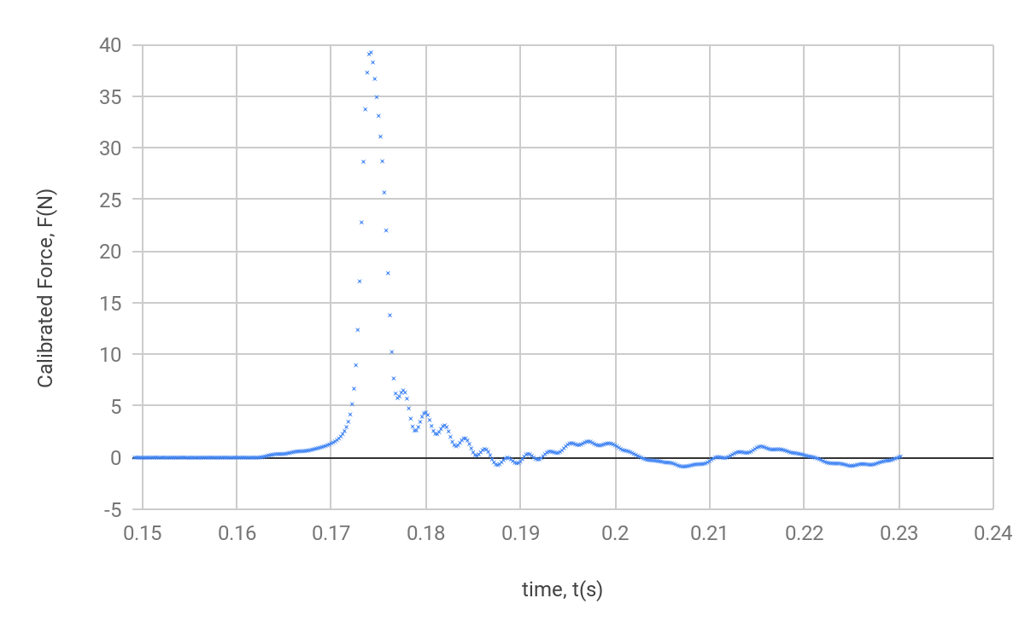

**Figure 2. Calibrated Force Versus Time, Trial 1**

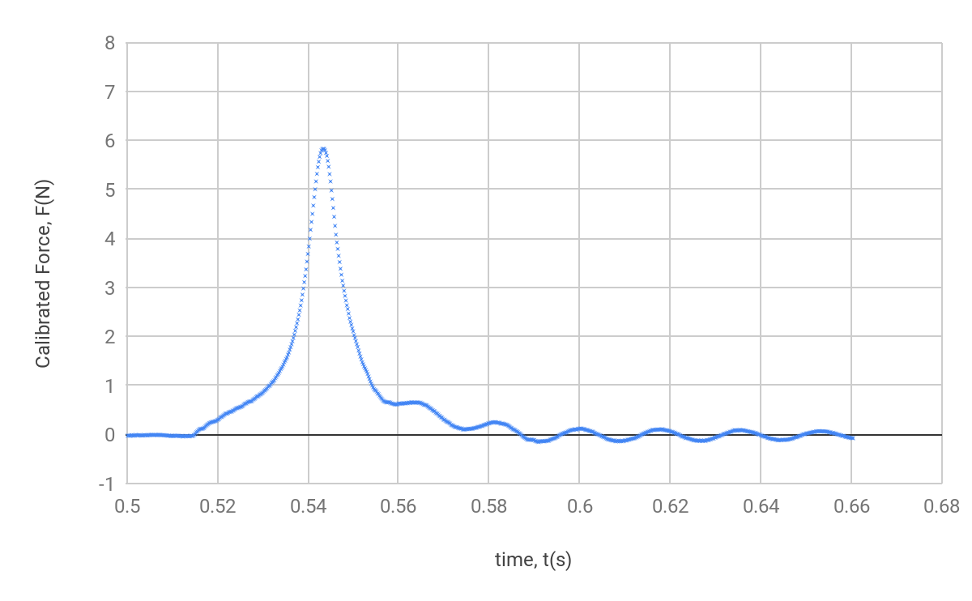

**Figure 3. Calibrated Force Versus Time, Trial 2**

In method 2, the impulse is calculated using the following formula:

$Δp=\int_{t_{1}}^{t_{2}}{}F(t)dt$

To approximate the numerical integration, we used the Riemann sum and midpoint rule. Then,

$Δp≈\sum_{i=1}^{n}{}Δt×\underline{F}$,

where

$Δt=t_{2}-t_{1}$ and $\underline{F}=\frac{F_{1}+F_{2}}{2}$

Another column of data was produced by taking the average current and succeeding force measurements and dividing by the change in time. Then to calculate the impulse by integration, this new column of data was added together. While technically only the sum of the data in the peak contributes to the impulse, all the data beyond the peak, including the fluctuations, averages to zero.

The fractional uncertainty in impulse is equal to that of the force sensor calibration constant:

$\frac{δc}{c}=\frac{δp}{p}$

Trial 1 (data represented in Figure 2):

$Δp≈\sum_{i=1}^{n}{}Δt×\underline{F}= 0.1526=8±0.0007 kg\frac{m}{s}$

Trial 2 (data represented in Figure 3):

$Δp≈\sum_{i=1}^{n}{}Δt×\underline{F}=0.0831±0.0003 kg\frac{m}{s}$

Results:

All data are measurements of impulse, and are in units of $kg\frac{m}{s}$.

|  |  |  |
| --- | --- | --- |
|  | Trial 1 | Trial 2 |
| Method 1 | 0.1606 $±$ 0.00004 | 0.0889 $±$ 0.00002 |
| Method 2 | $0.1526=8±0.0007$ | $0.0831±0.0003$ |

**Table 1.**

**Extra Credit**

To calculate coefficient of restitution $C_{R}$, we set up two photogates spaced some distance apart, and had the gliders collide in between the photogates so that they would record four velocities (both the incoming and outgoing velocities for each of the two gliders).

Glider 1:

$m_{1}=205.0±0.05 g$

$l_{1}=3.70±0.05 cm$

Glider 2:

$m_{2}=202.0±0.05 g$

$l_{2}=3.80±0.05 cm$

Data tables for trials one and two are presented below. In trial 1, bumpers were attached to the colliding ends of the gliders and in trial 2, bumpers were removed. In each, relative initial speed is calculated by taking the magnitude of the difference between the initial speeds for gliders one and two, and the same method is used for relative final speed, except with the final speeds of gliders one and two.

Trial 1:

|  |  |  |  |
| --- | --- | --- | --- |
|  | Glider 1 Speed $(m/s)$ | Glider 2 Speed $(m/s)$ | Relative Speed $(m/s)$ |
| Initial | 0.4913 | -0.5187 | 1.01 |
| Final | -0.1155 | 0.184 | 0.2995 |

**Table 2.**

Coefficient of Restitution:

$C_{R}=\frac{final relative speed}{initial relative speed}=\frac{0.2995}{1.01}=0.2965$

Since $C_{R}$ is close to 0, so this collision had great inelasticity.

Trial 2:

|  |  |  |  |
| --- | --- | --- | --- |
|  | Glider 1 Speed $(m/s)$ | Glider 2 Speed $(m/s)$ | Relative Speed $(m/s)$ |
| Initial | 0.943 | -0.2621 | 1.2051 |
| Final | 0* | 0.1439 | 0.1439 |

**Table 3.**

*The final speed of glider one did not have enough momentum to reach the photogate for a final speed measurement, but it’s motion appeared negligible. Nevertheless, some momentum went unaccounted for.

Coefficient of Restitution:

$C_{R}=\frac{final relative speed}{initial relative speed}=\frac{0.1439}{1.2051}=0.1194$

Since the coefficient of restitution for the second trial is smaller than that for the first trial, there is greater inelasticity in the second collision, and more energy was dissipated on impact.

Calculations of Degree of Conservation of Energy and Momentum

Trial 1:

|  |  |  |  |  |
| --- | --- | --- | --- | --- |
|  | Glider 1 Energy (J) | Glider 2 Energy (J) | Glider 1 Momentum (Ns) | Glider 2 Momentum (Ns) |
| Initial | 0.02474 | 0.027174 | 0.10072 | -0.104777 |
| Final | 0.001367 | 0.003419 | -0.023678 | 0.037352 |

**Table 4.** In each cell, results for calculations for energy or momentum are given. Energy was calculated using the formula $E=\frac{1}{2}mv^{2}$, and momentum calculated from $p=mv$.

Total Initial Energy: $E_{i}=0.02474 J+0.027174 J=0.05195 J$

Total Final Energy: $E_{f}=0.001367 J+0.003419 J =0.0047868 J$

Dissipated Energy: $ΔE=E_{i}-E_{f}=0.05195 J-0.0047868 J=0.047128 J$

Total Initial Momentum: $p_{i}=0.10072 Ns-0.104777 Ns=-0.0040609 Ns$

Total Final Momentum: $p_{f}=-0.0236775 Ns+0.037352=0.01367 Ns$

Momentum Lost: $Δp=p_{i}-p_{f}=-0.01774 Ns$

Trial 2:

|  |  |  |  |  |
| --- | --- | --- | --- | --- |
|  | Glider 1 Energy | Glider 2 Energy | Glider 1 Momentum | Glider 2 Momentum |
| Initial | 0.091148 | 0.006938 | 0.193315 | -0.0529 |
| Final | 0 | 0.00209 | 0 | 0.029068 |

**Table 5.** The methods used to obtain the numbers presented in this table is the same as what was done in table four, but for different numbers from a different trial.

Total Initial Energy: $E_{i}=0.091148 J+0.006938 J=0.098086 J$

Total Final Energy: $E_{f}=0 J+0.0.00209 J =0.00209 J$

Dissipated Energy: $ΔE=E_{i}-E_{f}=0.098086 J-0.00209 J=0.09599 J$

Total Initial Momentum: $p_{i}=0.193315 Ns-0.0529 Ns=0.14037nNs$

Total Final Momentum: $p_{f}=-0.0236775 Ns+0.037352=0.0290678 Ns$

Momentum Lost: $Δp=p_{i}-p_{f}=0.111303 Ns$

**Presentation Mini-Report**

**Introduction**

Impulse is the measurement of the change in linear momentum of a collider, and is in some sense more “fundamental” than energy because in both elastic and inelastic collisions, linear momentum is conserved, whereas energy dissipation is certainly a given in an experimental setting. Thus, analyzing momentum in a system is important because it is easier to keep track of, and makes less room for error. This experiment aims to verify two methods of calculating impulse.

Since momentum is given by $p=mv$ and is expressed in units of $kg\frac{m}{s}$, the impulse is expressed in the same units since it is merely a difference of two momentum terms. This method of calculating impulse requires just values of initial velocity, final velocity, and mass. A second method involves taking the integral of force over the duration of the collision. This gives units of *Ns,* which when expressed in terms of fundamental units and rearranged, is the same as $kg\frac{m}{s}$. The data we collected from the two methods came from a photogate which recorded the incoming and returning velocities of the glider as it collided with the force sensor, and a force sensor which returned voltage recordings at extremely high frequency because the duration of the collision takes place within a few fractions of a second. The data from the force sensor was plotted in a graph, and the area under the curve was taken to calculate the impulse of the collision. The results of these two methods are then compared, and are expected to be nearly equivalent.

Word Count: 260

**Methods**

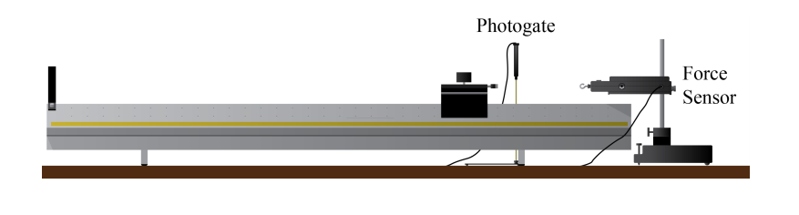

**Figure 4. Experimental Setup for Impulse Calculation1**

The first step we took was to calibrate the force sensor. This was done by connecting the force sensor to PASCO so readings of voltage could be recorded as various masses (5g,10g,35g,40g,45g,100g) were allowed to hang freely from the sensor. Then a graph was created which graphed each voltage recording against the measured mass multiplied by 9.8 (which gave us the gravitational force on the mass). Then a line of best fit was created. The slope of this line is the calibration constant.

Before the experiment was set up, we measured the mass of the glider and flag combined and the length of the flag, with respective uncertainties. PASCO is set up such that the photogate and force sensor are selected in Tools/Hardware, and a new pre-configured timer is set up for the photogate (single flag). As the experiment is being run, three columns of data are generated. One of time data points in seconds, one of voltages in Volts (User Defined), and another speed in meters per second. The column containing speed measurements contained only two data points—one was a measurement of the initial velocity, and the second was a measurement of the final velocity. The sampling rate is set to 7.00 kHz, and records in continuous mode, since the data collected from impact takes place over a few tenths of a second.

In performing the actual experiment, a setup was prepared as shown in Figure 4. A photogate was set up a certain distance away from the force sensor, and in front of the glider’s initial position so that the photogate will measure the velocity once as it glides towards the force sensor, and once as it bounces back. The force sensor was held horizontally by metal clamps so the hook aligned with the bumper of the glider so it could accurately record force data. Data from two trials were collected.

Then the calculation of impulse from method one involved only measurements of mass, and the initial and final velocities, using the formula $Δp=m(v_{f}-v_{i})$.

To obtain a measurement of impulse from the second method, columns of data of time and voltage were imported into Google Sheets from PASCO and modified to create a column of calibrated and zeroed force values, which were then plotted against time. To obtain the column of desired force values, raw voltage data from PASCO was calibrated by multiplying each value by 6.2369. Then, an estimate of the baseline force was obtained by averaging the first one hundred or so data points (before the glider collided with the force sensor) and then subtracted from each calibrated force data point. Now, when no force is being exerted on the force sensor, the reading will only fluctuate around zero, as expected. A scatter plot was created which graphed these new calibrated force values against the unchanged time data collected from PASCO. Then in Google Sheets, a new column was created of the average of each current and succeeding force value was multiplied by the difference between the current and succeeding time stamps. This gives the value of the area of each small rectangle whose height is determined by the average of the nearest two force values and whose width is the change in time. Then, the entire column was summed over, which is how we performed Riemann sum using midpoint rule. This sum gave us our calculation of impulse from the second method.

As expected, the impulse values obtained from the two methods are close and within 0.01 $kg\frac{m}{s}$ of each other.

**Works Cited**

[1] Campbell, W.C. et al. Physics 4AL: Mechanics Lab Manual. UCLA Department of Physics and Astronomy. 64:64. 2018.